Danske penge - danish money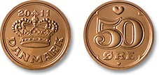 50 øre = 0,50 dkr
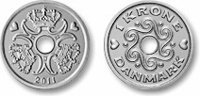 1 dkr
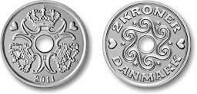 2 dkr
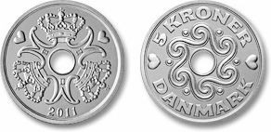 5 dkr
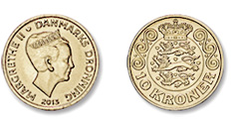 10 dkr 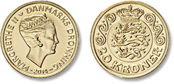 20 dkr

Danske pengesedler.

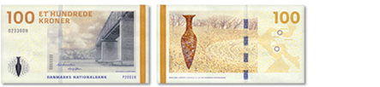
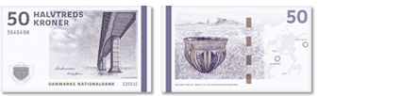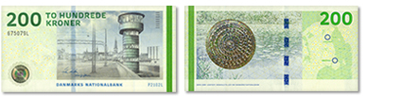
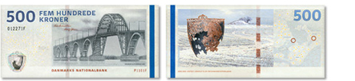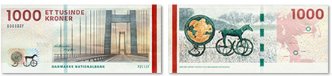

Danish banknotes:
The theme of the banknotes is Danish bridges and surrounding landscapes or details from these landscapes. The artist Karin Birgitte Lund has chosen to interpret the theme in two ways: Bridges as links between parts and bridges as a link between past and present. Present is represented by the bridges, the past is represented by five distinctive prehistoric objects found near the bridges.
What can you buy?
10 dkr 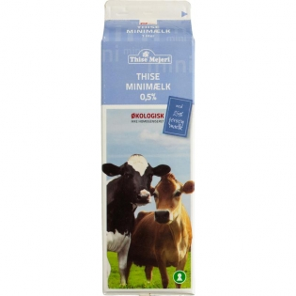

20 dkr 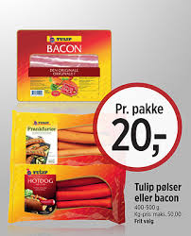

50 dkr 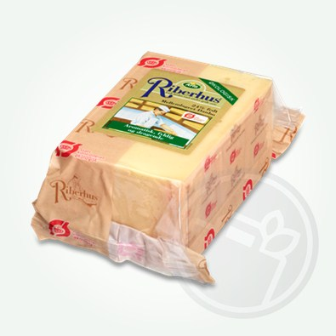
100 dkr 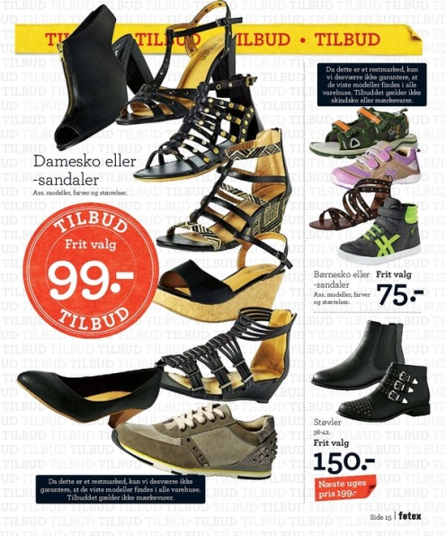

200 dkr

500 dkr 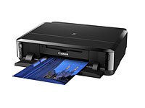

Exchange from euro - dkr
1 euro = 7,50 dkr
2 euro = 15,00 dkr
5 euro = 37,50 dkr
10 euro = 75 dkr
100 euro = 750 dkr
1000 euro = 7500 dkr

