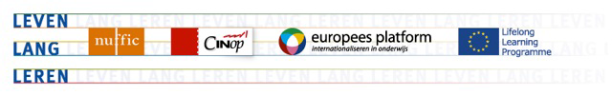

UNESCO Wold Heritage List - The Netherlands

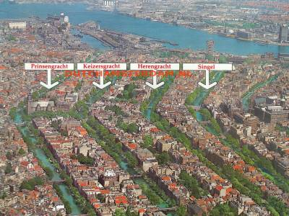 | Seventeenth-Century Canal Ring Area of Amsterdam inside the Singelgracht  The historic urban ensemble of the canal district of Amsterdam was a project for a new ‘port city’ built at the end of the 16th and beginning of the 17th centuries. It comprises a network of canals to the west and south of the historic old town and the medieval port that encircled the old town and was accompanied by the repositioning inland of the city’s fortified boundaries, the Singelgracht. This was a long-term programme that involved extending the city by draining the swampland, using a system of canals in concentric arcs and filling in the intermediate spaces. These spaces allowed the development of a homogeneous urban ensemble including gabled houses and numerous monuments. This urban extension was the largest and most homogeneous of its time. It was a model of large-scale town planning, and served as a reference throughout the world until the 19th century.  (since 1999)
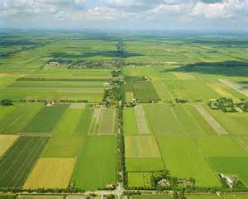 | Droogmakerij de Beemster (Beemster Polder)  The Beemster Polder, dating from the early 17th century, is is an exceptional example of reclaimed land in the Netherlands. It has preserved intact its well-ordered landscape of fields, roads, canals, dykes and settlements, laid out in accordance with classical and Renaissance planning principles.  (since 1999)
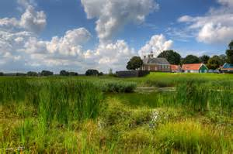 | Schokland and Surroundings  Schokland was a peninsula that by the 15th century had become an island. Occupied and then abandoned as the sea encroached, it had to be evacuated in 1859. But following the draining of the Zuider Zee, it has, since the 1940s, formed part of the land reclaimed from the sea. Schokland has vestiges of human habitation going back to prehistoric times. It symbolizes the heroic, age-old struggle of the people of the Netherlands against the encroachment of the waters.  (since 1995)
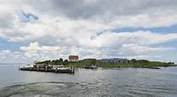 | Defence Line of Amsterdam  Extending 135 km around the city of Amsterdam, this defence line (built between 1883 and 1920) is the only example of a fortification based on the principle of controlling the waters. Since the 16th century, the people of the Netherlands have used their expert knowledge of hydraulic engineering for defence purposes. The centre of the country was protected by a network of 45 armed forts, acting in concert with temporary flooding from polders and an intricate system of canals and locks.  (since 1960)
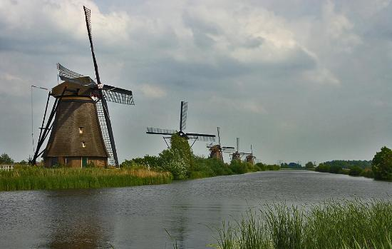 | Mill Network at Kinderdijk-Elshout  The outstanding contribution made by the people of the Netherlands to the technology of handling water is admirably demonstrated by the installations in the Kinderdijk-Elshout area. Construction of hydraulic works for the drainage of land for agriculture and settlement began in the Middle Ages and have continued uninterruptedly to the present day. The site illustrates all the typical features associated with this technology – dykes, reservoirs, pumping stations, administrative buildings and a series of beautifully preserved windmills.  (since 1997)
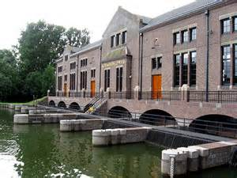 | Ir.D.F. Woudagemaal (D.F. Wouda Steam Pumping Station), Lemmer, Frisia  The Wouda Pumping Station at Lemmer in the province of Friesland opened in 1920. It is the largest steam-pumping station ever built and is still in operation. It represents the high point of the contribution made by Netherlands engineers and architects in protecting their people and land against the natural forces of water.  (since 1998)
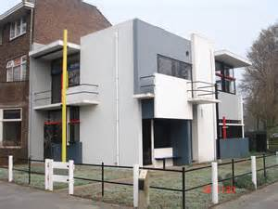 | Rietveld Schröderhuis (Rietveld Schröder House), Utrecht  The Rietveld Schröder House in Utrecht was commissioned by Ms Truus Schröder-Schräder, designed by the architect Gerrit Thomas Rietveld, and built in 1924. This small family house, with its interior, the flexible spatial arrangement, and the visual and formal qualities, was a manifesto of the ideals of the De Stijl group of artists and architects in the Netherlands in the 1920s, and has since been considered one of the icons of the Modern Movement in architecture.  (since 2000)
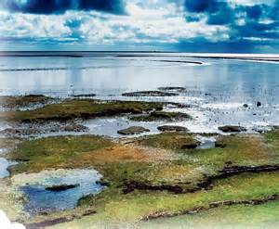 | Wadden Sea  This is an extension of the Dutch and German Wadden Sea site, inscribed on the World Heritage List in 2009. The Wadden Sea is the largest unbroken system of intertidal sand and mud flats in the world. The complete extension now covers most of the Danish Wadden Sea maritime conservation area, as well as a maritime extension of the Dutch Wadden Sea Conservation Area and the German Wadden Sea National Parks of Lower Saxony and Schleswig-Holstein.  (since 2009)
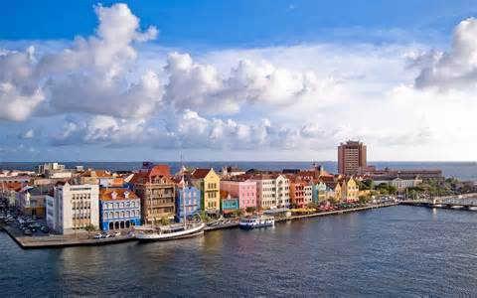 | Historic Area of Willemstad, Inner City and Harbour, Curaçao  The people of the Netherlands established a trading settlement at a fine natural harbour on the Caribbean island of Curaçao in 1634. The town developed continuously over the following centuries. The modern town consists of several distinct historic districts whose architecture reflects not only European urban-planning concepts but also styles from the Netherlands and from the Spanish and Portuguese colonial towns with which Willemstad engaged in trade.  (since 1997)
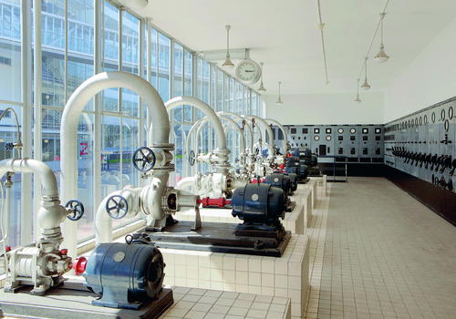 | Van Nelle Factory, Rotterdam  Van Nellefabriek (Netherlands) was designed and built in the 1920s on the banks of a canal in the Spaanse Polder industrial zone northwest of Rotterdam. The site is one of the icons of 20th century industrial architecture, comprising a complex of factories, with facades consisting essentially of steel and glass, making large-scale use of the curtain wall principle. It was conceived as an “ideal factory”; open to the outside world, whose interior working spaces evolved according to need, and in which daylight was used to provide pleasant working conditions. It embodies the new kind of factory that became a symbol of the modernist and functionalist culture of the inter-war period and bears witness to the long commercial and industrial history of the Netherlands in the field of importation and processing of food products from tropical countries, and their industrial processing for marketing in Europe.  (since 2014)

