Get Set Go Van Leersum Travel
As part of the Comenius project Get Set Go we focused more on traveling this year.
Traveling is important for an independent life. Yet traveling by yourself using public transport seems to be a fading art. We noticed that children travel by train far less than in the old days. As families now have one or more cars people tend to drive to a place rather than go by train or bus.
And yet growing up and going to secondary education or living on your own and having to travel to your work makes it important for our students to know how you use the public transport system.
Because in a city it is often the most convenient way of travelling and sometimes because our pupils don’t succeed in obtaining a good understanding of traffic and traffic rules. So they depend on it.

We used existing public transport apps to show, how you can plan a journey. From any of the four upper grade classes two pupils were chosen to make a real trip. We decided to make a trip to a nearby city that is not too large or too busy. Together we bought tickets at the ticket machine, walked to the platform, checked if it was the right train arriving and got in. And of course we also got out in time.
Getting into and out of the train was a problem for some children. There is a gap between the train and the platform. That is frightening.
In a town there are busy roads that you have to cross. And even when there are traffic lights that is a bit scary too.
And it was fortunate that if you don’t know your way about there was someone with you that could point out the help there is in the streets.
We discovered that they put up signs to show you into what direction you should go to the town centre or to a certain museum or a city gate. We talked about the agreement that was made to give these signs the same appearance everywhere so that you would know what to look for. That is reassuring.
The visit to the town of Amersfoort was not just learning it was fun too. A lot of our pupils like maps. So it was quite interesting to see the exact starting point map makers use for their maps.
And also the enormous boulder had its own and interesting story. As did the unique road and water gate at the point the river Eem leaves the city.
And oh yes we discovered that not only Amsterdam has circular boat trips or the special Dutch facades. Amersfoort has them too.
I wished we could have more of these trips with small groups of children. . . . .

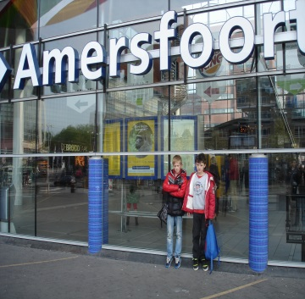 | 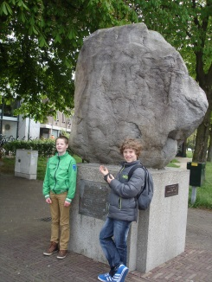 | 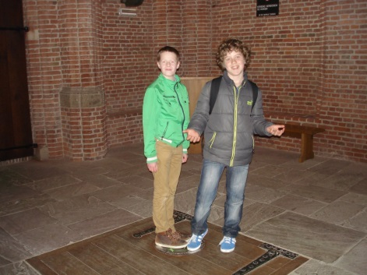
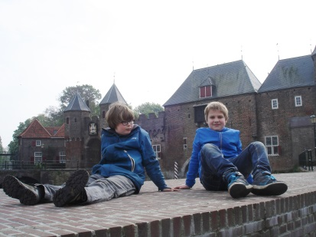 | 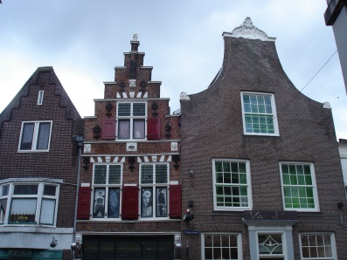 | 