CHRISTMAS RECIPE from SALESIANS BADALONA

CANNALLONI (5 people)
INGREDIENTS:
500g Mix Chicken/Pork Minced Meat
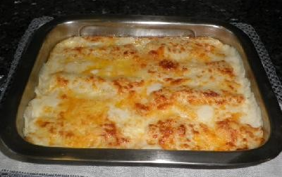
15-20 cannelloni pasta (round or slide)
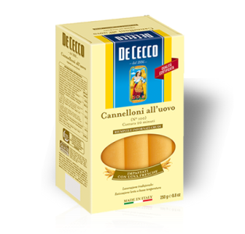
1 Onion
Olive oil
Salt
20 cl milk
10g butter
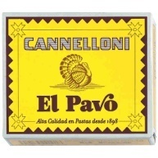
20 g flour

Bechamel sauce:
1 litre milk
50g butter
20g flour
1 pack Grate cheese

TOOLS:
Blender
Knife
2 Pans
Tray
Oven

DIRECTIONS:
- Fry all meat in a big pan until roasted. Use olive oil for cooking and don’t forget to add salt.
- Chop onion with hand blender.
- In a big pan, fry chopped onion with a little olive oil. When toasted, turn down the heat, add flour and mix. After 2 minutes, add milk and mix until compact. The mix must be a little liquid to absorb the meat later on.
- Add meat to sauce obtained and mix well.
- Fill the cannelloni pasta with the meat mix and roll them one by one like a cylinder. Place them on a tray covered with a little butter.

Béchamel sauce:
- In a separate pan, melt the butter and add flour and salt. When compact, add milk little by little to avoid lumps. Then turn the heat up and keep moving until it becomes thicker.
- Add béchamel sauce over the cannelloni.
- Cover with cheese.
- Put in the oven for 10 minutes, 200ºC.

ENJOY YOUR MEAL!!!

