Pound to Euro Exchange rate 1.00 Pounds | = | 1.25412 EURO
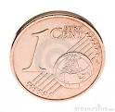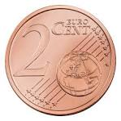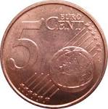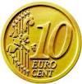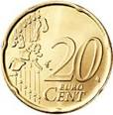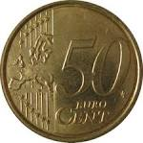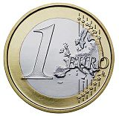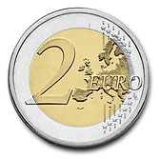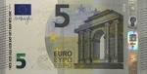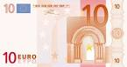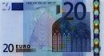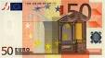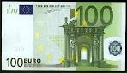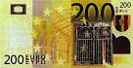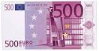
The Euro was introduced on December 16th 1995; Austria, Belgium, Cyprus, Estonia, Finland, France, Germany, Greece, Southern Ireland, Italy, Latvia, Luxembourg, Malta, the Netherlands, Portugal, Slovakia, Slovenia and Spain use it. The euro is one of the major reserve currencies together with the U.S. dollar, Japanese yen, Pound sterling and Swiss franc.

