UK currency 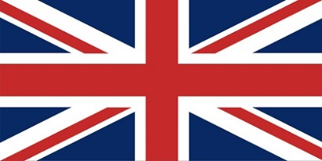

Notes

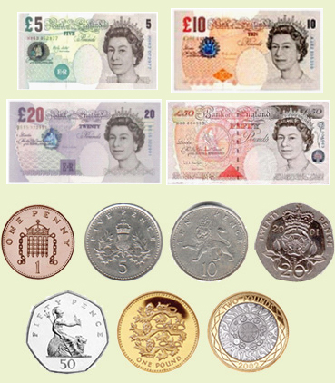

Costs of some foods

|  |  |  |
| --- | --- | --- |
| Item picture | Item | Cost |
|  | Mars Bar | 60p |
|  | Can of coke | 65p |
|  | Loaf of bread | £1 |
|  | 4 pints of Milk (2.27 litres) | £1 |
|  | A bag of crisps | 55p |