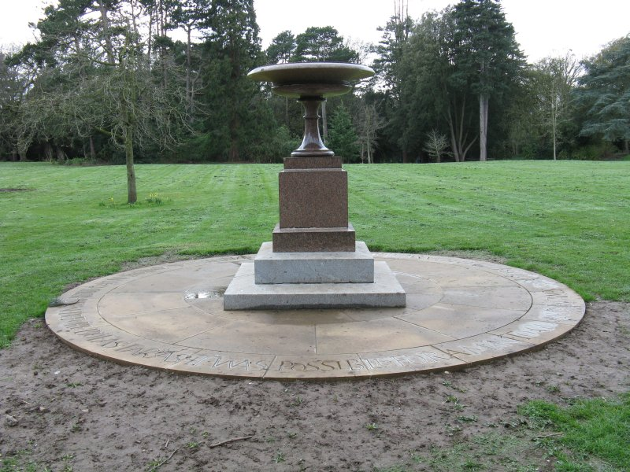
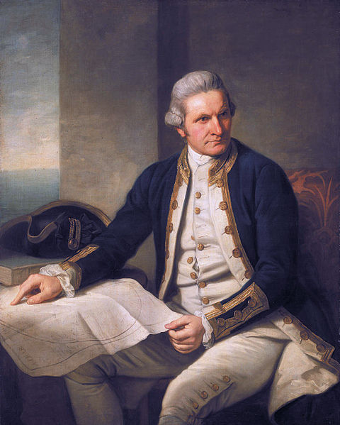
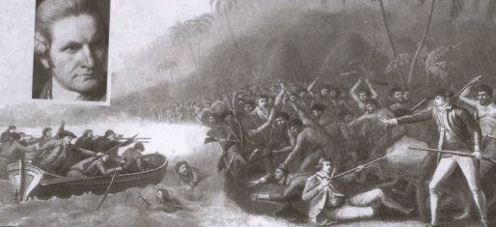
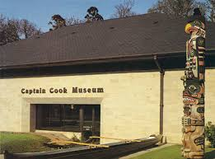
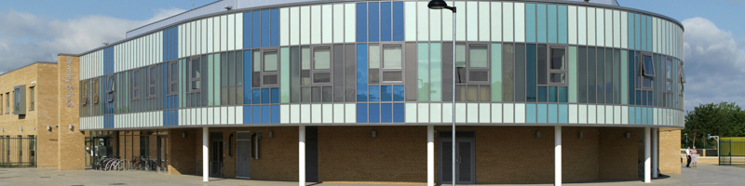
The tour
of
Middlesbrough

Urn marking the site of Captain Cook’s birth.

Captain Cook Museum
A public museum in Stewarts Park in Middlesbrough. It celebrates the life, times and journeys of Captain James Cook the British explorer and navigator who was born in Middlesbrough.

Beverley School for Children with Autism
 

Planned and delivered by pupils from Beverley School.
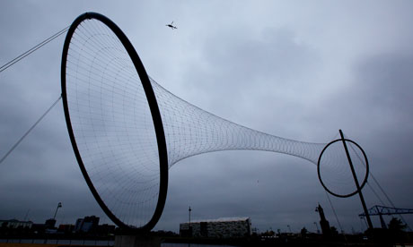
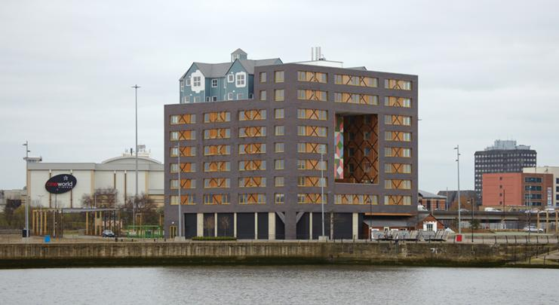
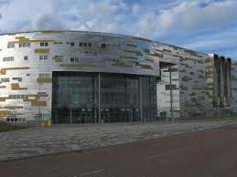
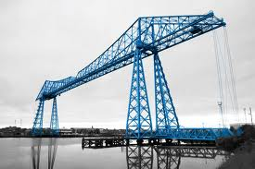
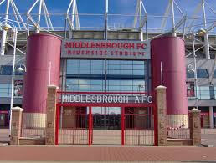

Middlehaven

Temenos designed by world famous sculptor Anish Kapoor. It is next to the River Tees in the Middlehaven area of Middlesbrough.
CIAC – Community In A Cube
The CIAC is a place for people to live in. It is in Middlehaven. It is supposed to show a new way of living and was said to be innovative in its design. This is an area of Middlesbrough that is going to be redeveloped.
Middlehaven is Middlesbrough's flagship regeneration area and includes world class residential, office, education, leisure and cultural developments.
Middlehaven is Middlesbrough's town centre north of the A66 and incorporates the dockside near Middlesbrough's Riverside Stadium and the landmark Transporter Bridge.
The regeneration area combines the preservation and renewal of historic buildings in Middlesbrough's original centre with striking and ambitious contemporary architecture and art.

